M:\Library\20180924_085304.tifM:\Library\20180924_085457.tif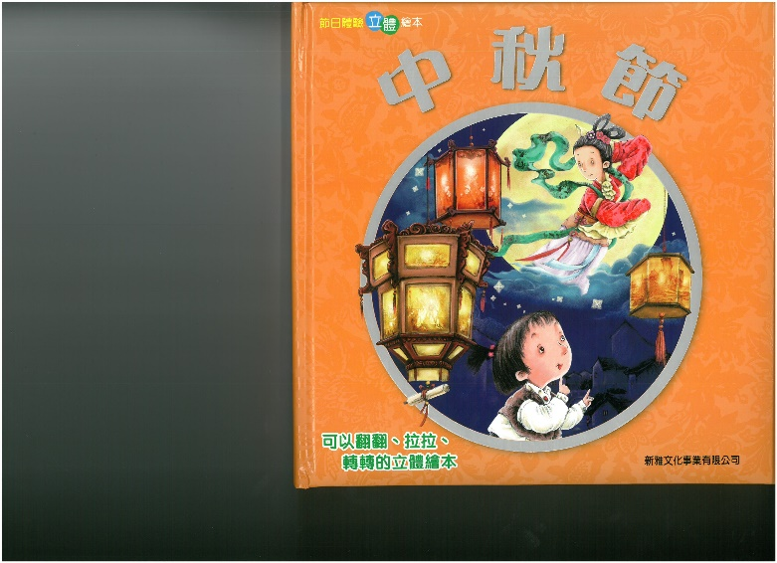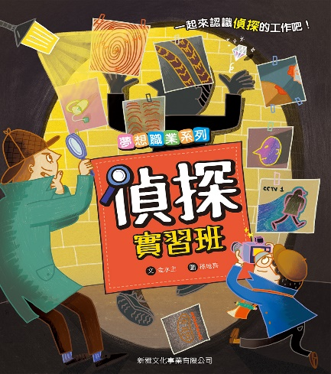

**等着你來借閱！記得帶智能卡啊！**

580 DAY

10-11月號(P.1-P.3)

圖書館新書推介

CP IWA

**等着你來借閱！記得帶智能卡啊！**

M:\Library\20180924_090019.tifM:\Library\20180924_085218.tifM:\Library\20180924_085936.tifM:\Library\20180924_085901.tifM:\Library\20180924_085826.tifM:\Library\20180924_085432.tif

951 NI

550 DAY

CF LIN

CF TRO

550 TRA

CP MIY

394 JU