

**等着你來借閱！記得帶智能卡啊！**



圖書館新書推介

550 TIA

**等着你來借閱！記得帶智能卡啊！**

M:\Library\20180924_085131.tifM:\Library\20180924_084943.tif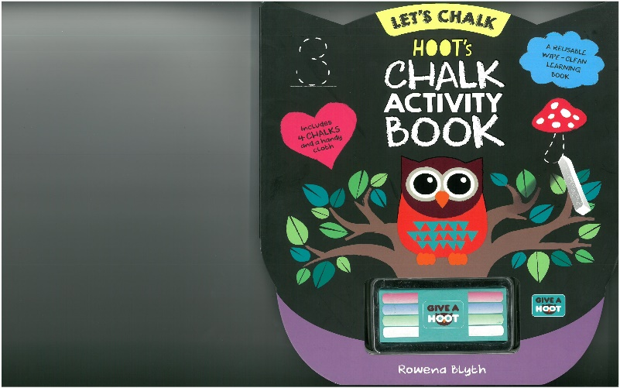M:\Library\20180924_084823.tifM:\Library\20180924_084752.tifM:\Library\20180924_084718.tifM:\Library\20180924_084635.tifM:\Library\20180924_084549.tifM:\Library\20180924_084504.tif

F GRI

F WES

CF CHA

700 JAC

CF MAI

793 BLY

495.1 CI

951 XIE